Prompt Engineering Technique
- Zero-Shot Prompting
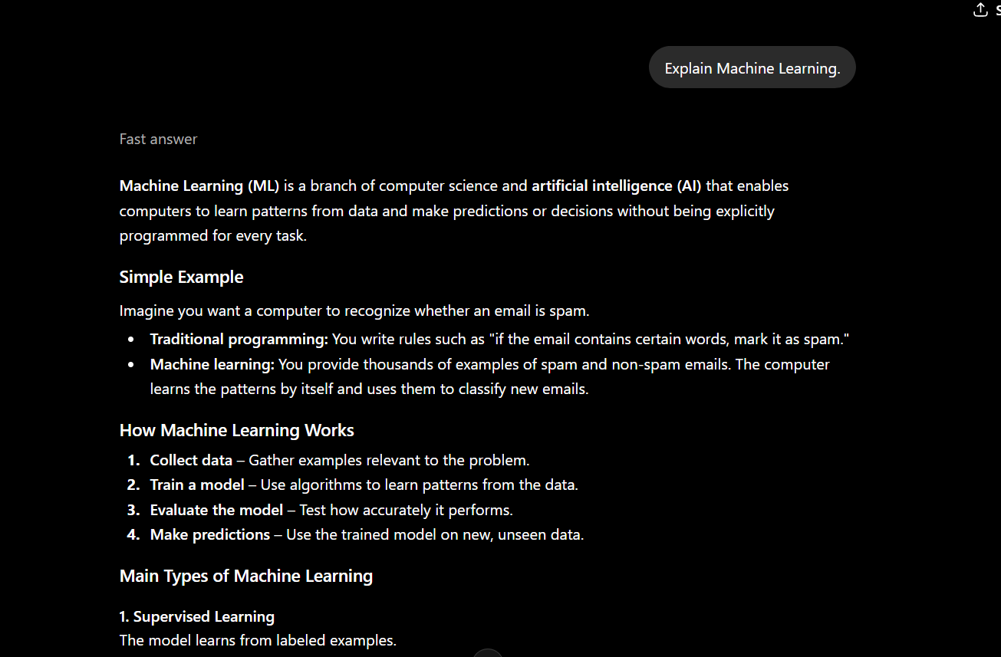

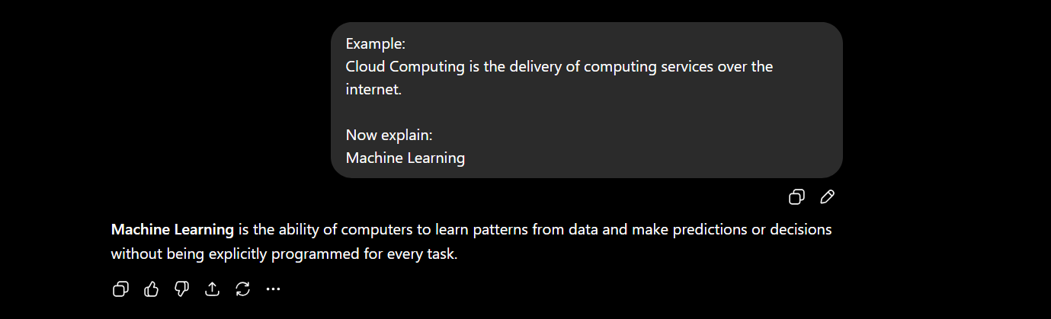
- One-Shot Prompting

- Few-Shot Prompting
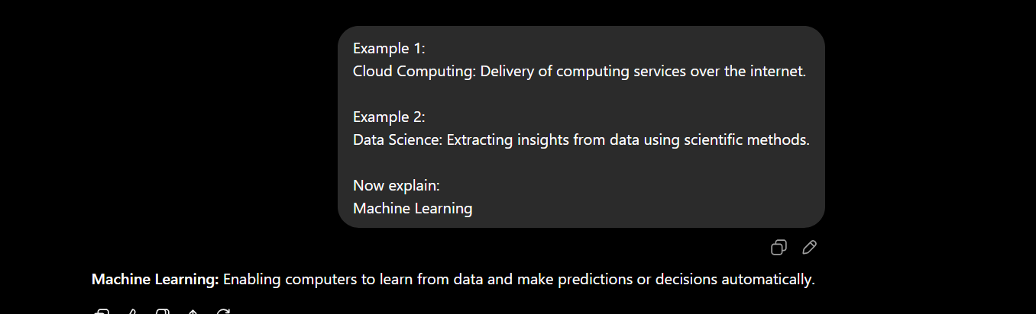
- Role-Based Prompting




- Chain of Thought (CoT)
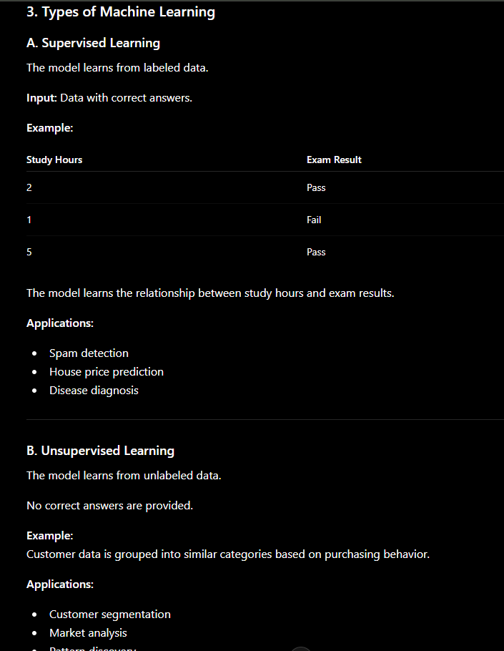
- Self-Consistency Prompting
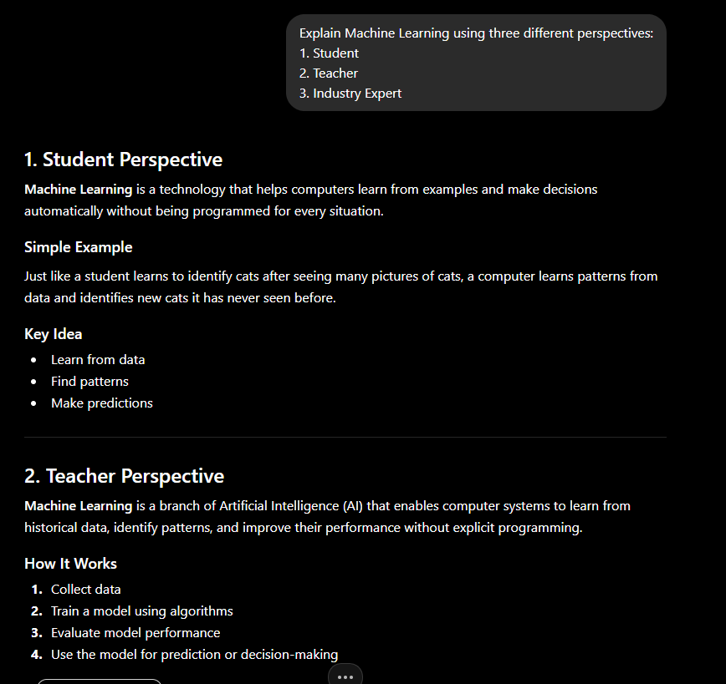

- Instruction-Based Prompting
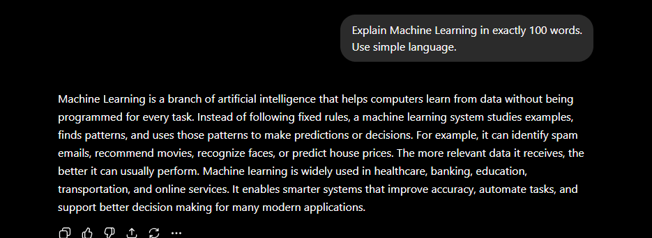

- Contextual Prompting
